Jenkins Assignment :-1
Select the new item and give Project name “job name” item type “job type”
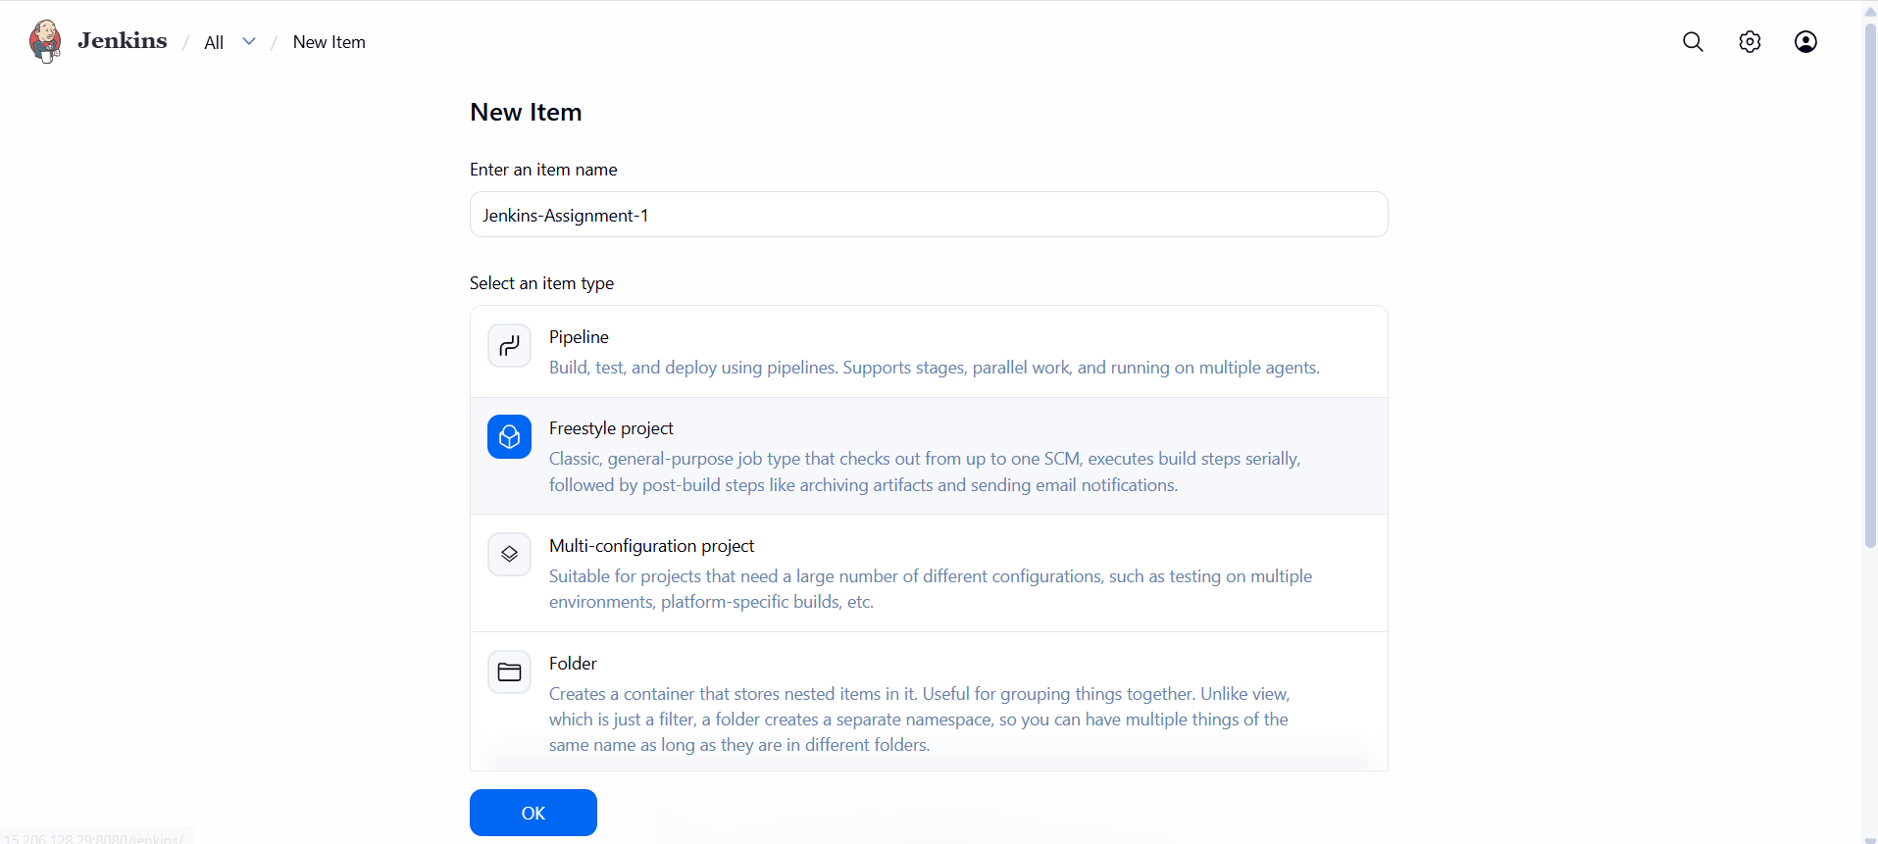

Step 2 give the description
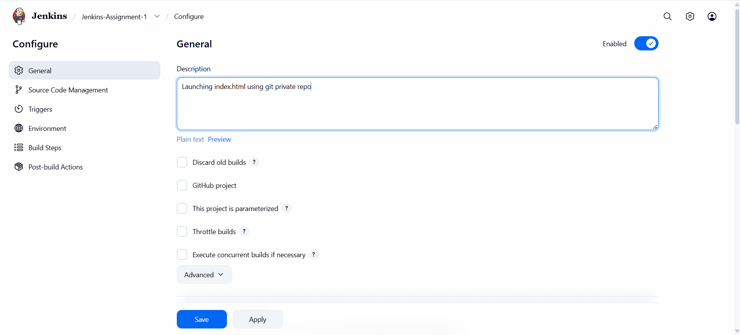
Step 3 :- In source Code Management need to give repo link
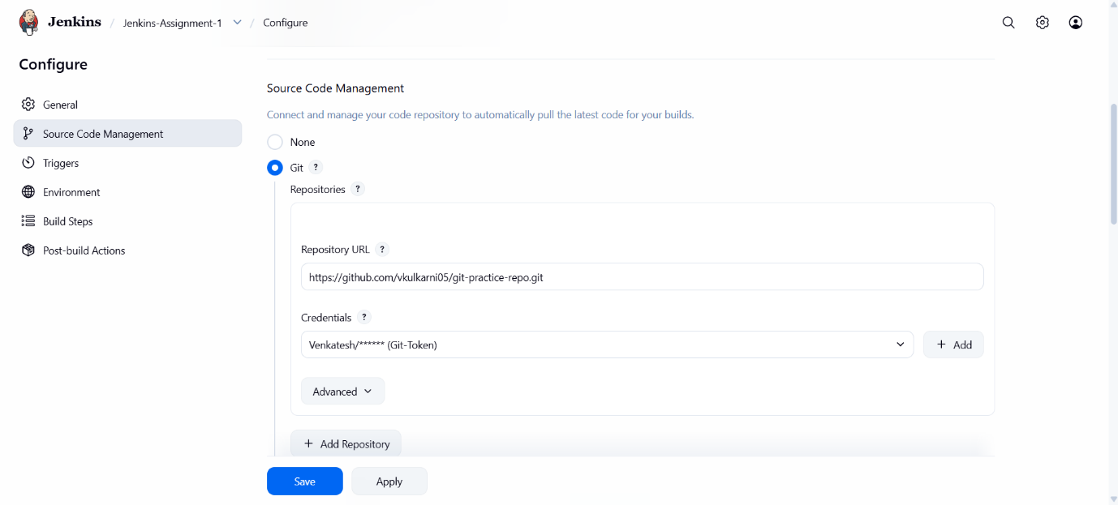
Our repo is private that’s way we need credentials and I have created already.

Step 4 :- mention the branch name in branch specifier
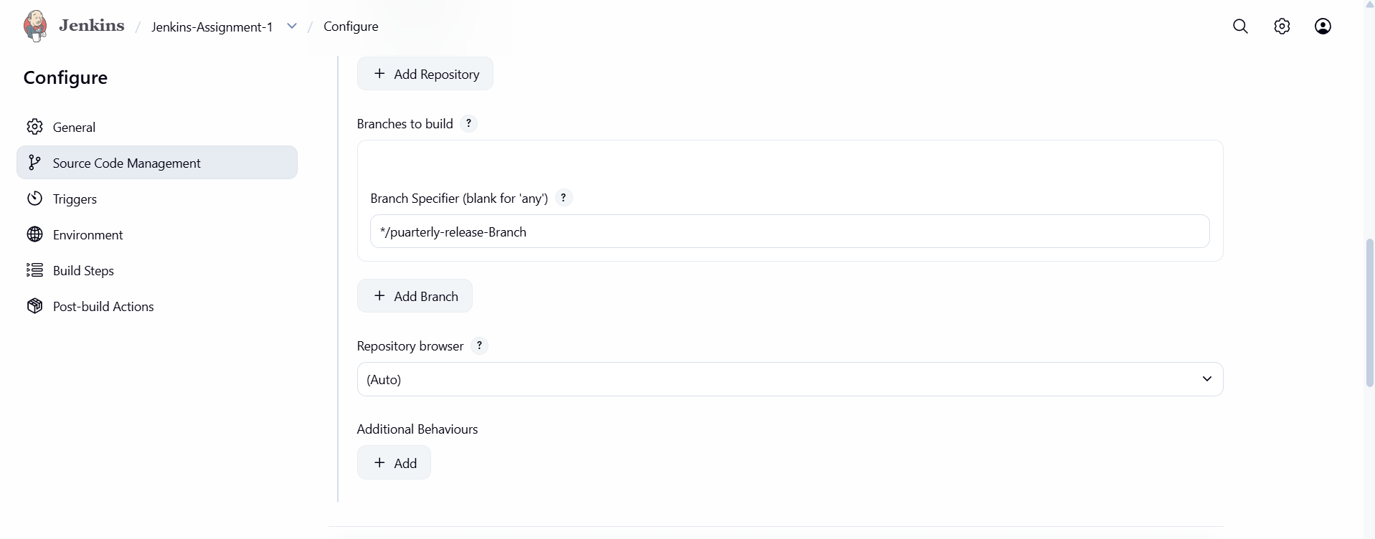

Step 5 in environment section need to select Delete workspace before build starts.
Its clears the Jenkins workspace
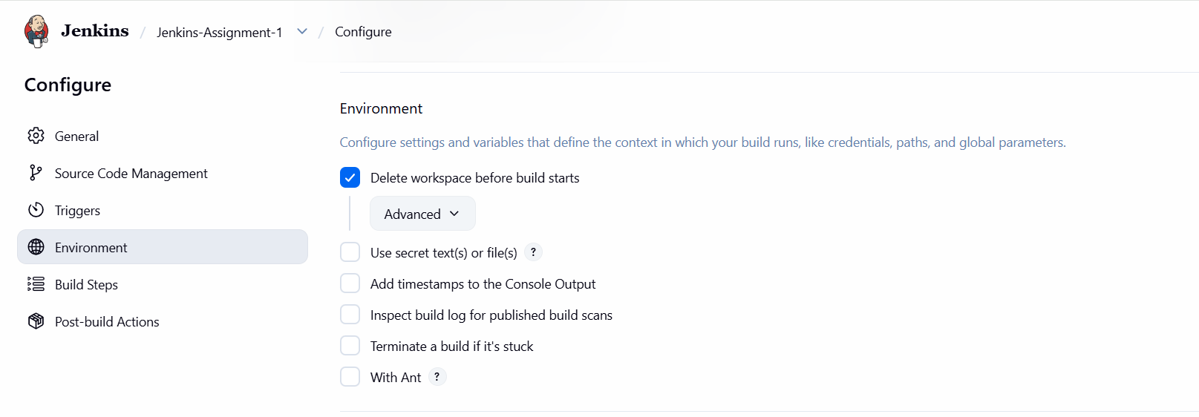
Step 6 :- in build steps select the Execute Shell and write the script to download the apache webserver and deploye the index.html
This is my script :-
## install apache webserver (httpd)
yum update -y
yum install httpd -y
systemctl start httpd
systemctl enable httpd
cp index.html /var/www/html/
systemctl restart httpd
chmod -R 777 /var/www/html/index.html

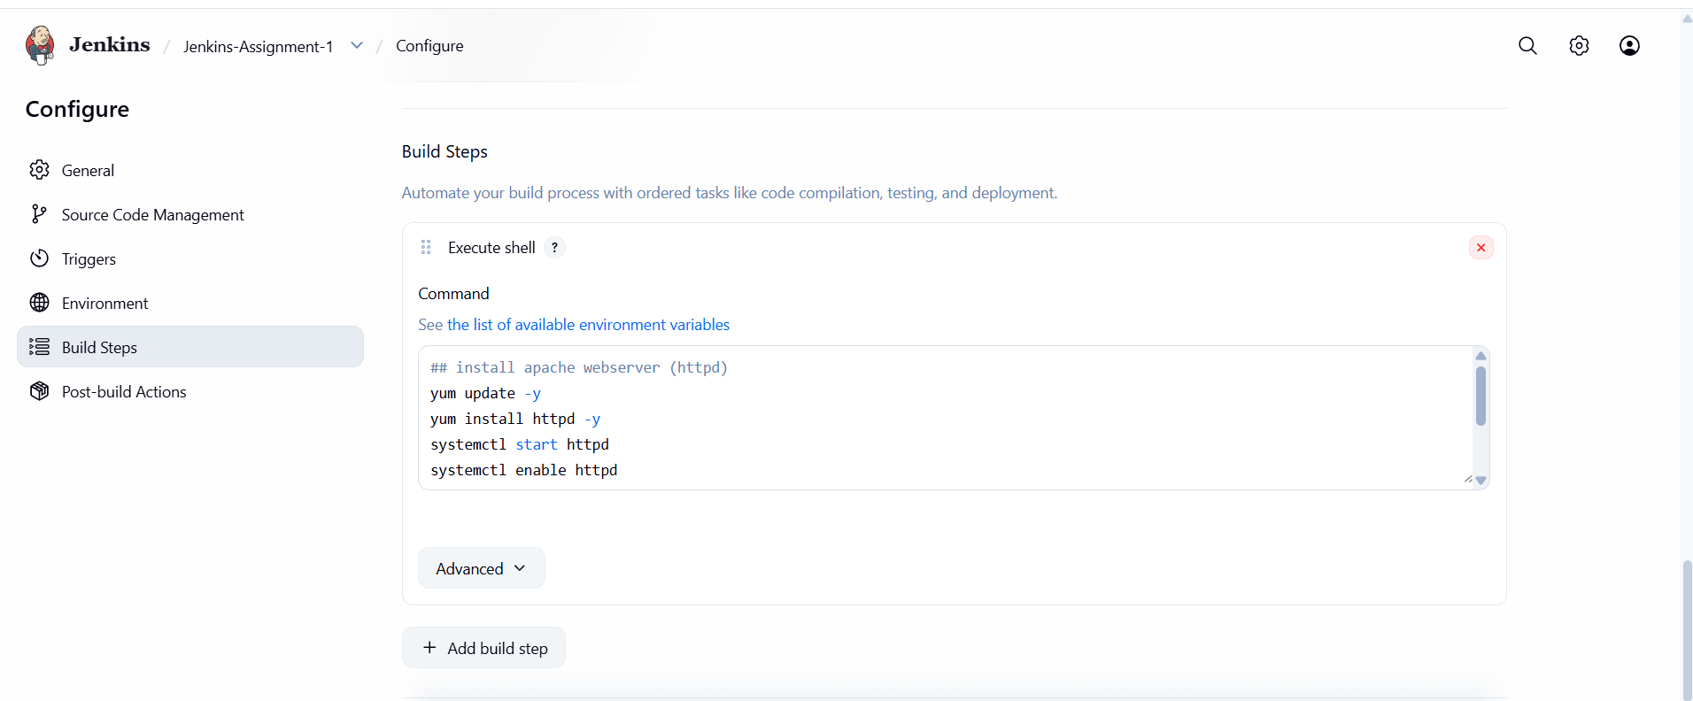

Step 7:- once done the apply and save the click on the build now button
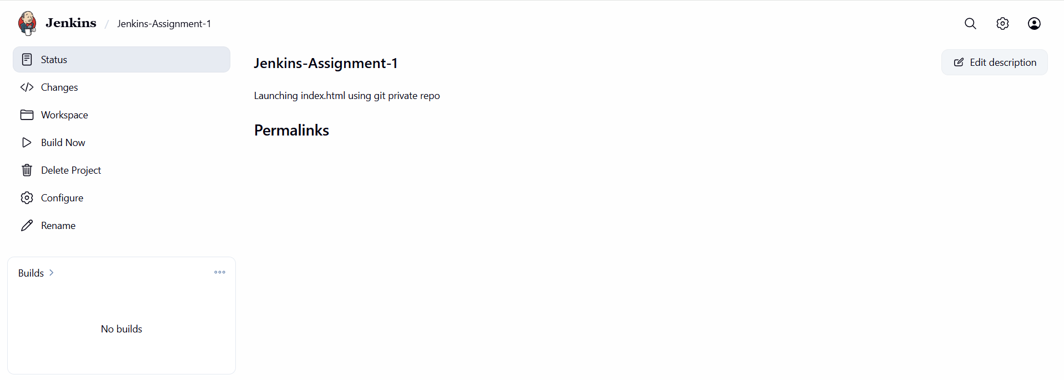

Step 8:- once click on build now the job is run successfully
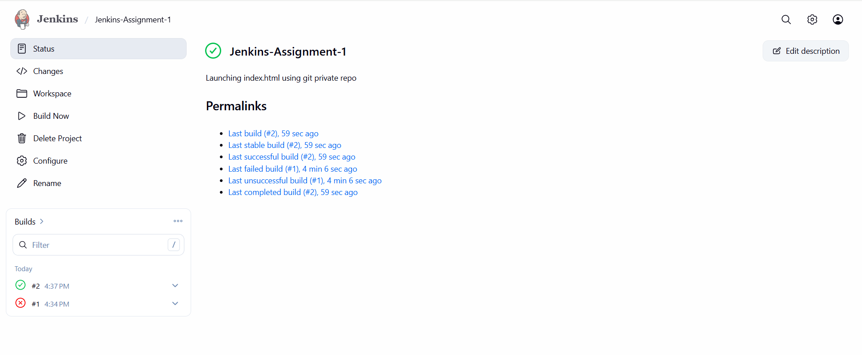
Console output
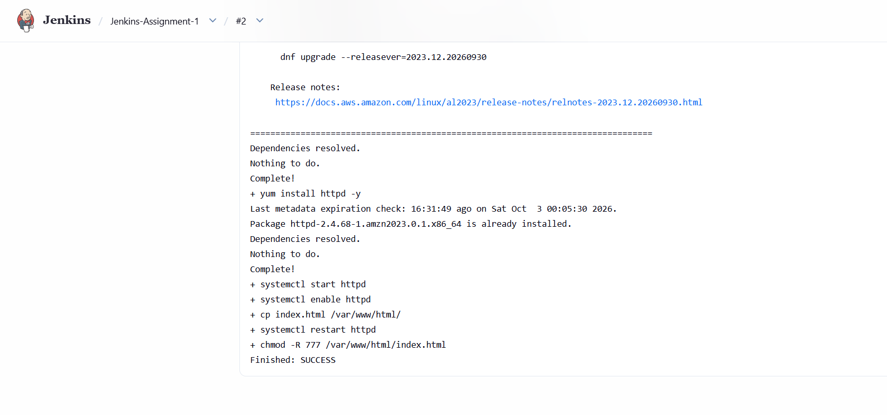
Final output :-
